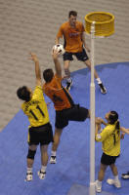
As part of National Korfball Week.

 The world’s ONLY mixed team sport
 Teams of 4 men and 4 women
 Fun and Friendly
 Some similarities to Netball and Basketball

Kelsey Kerridge Sports Hall,

Queens Anne’s Terrace, Cambridge
9 pm, Wednesday 15th September

For more info see www.korfball.co.uk or www.cambskorfball.co.uk

Contact David Bate (01462) 676328

As part of National Korfball Week.

 The world’s ONLY mixed team sport
 Teams of 4 men and 4 women
 Fun and Friendly
 Some similarities to Netball and Basketball

Kelsey Kerridge Sports Hall,

Queens Anne’s Terrace, Cambridge
9 pm, Wednesday 15th September

For more info see www.korfball.co.uk or www.cambskorfball.co.uk

Contact David Bate (01462) 676328

