Movement in Attack

The aim:
- Keep the ball moving at all times. If the ball stops, then the defenders can stop moving, making their job much easier
- Create shooting opportunities

Imagine you are connected to the post with a strong piece of elastic (a bit like a bungee run with the post at the end).

However the elastic is round your waist and is always in front of you (not behind you). | 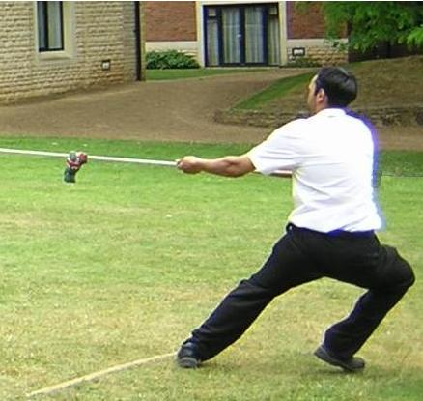
The elastic is strong enough that you can’t run round the post as it will pull you inwards. You must then pull on it to move away from the post. | 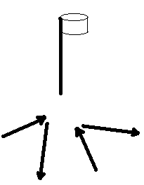

This means:
- You will move towards the post faster than you move away as the elastic will pull you inwards more quickly. This allows you to be under control as you receive the ball
- You cannot face away from the post as the elastic will turn you around
- You cannot stand still – the elastic is strong enough that it will always pull you towards the post unless you are actively trying to move away

“No bananas” – the elastic always makes you move in straight lines – either towards the post or away, never in curves | 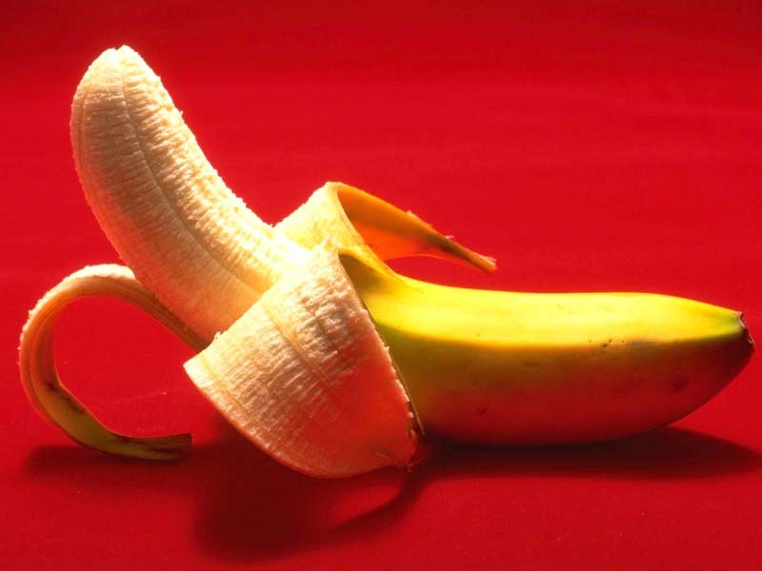

Moving away from the post
We know that we cannot face away from the post. If we try and run backwards we cannot move quickly and the elastic is likely to pull us over.
So we move sideways, like a crab. This allows us to:
- See where the ball is coming from
- Maintain balance
- Move quickly

The technique used is to take the foot closest to the post and cross it over the other foot, move the other foot away from the post and repeat.  We can use the hand closest to the post to “pull” on our elastic, making it easier to move away. | 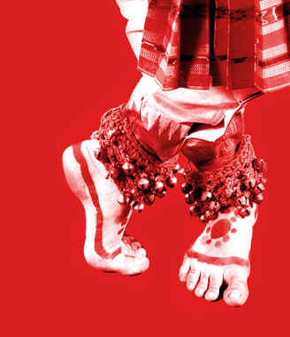
To indicate we are ready to receive the ball we hold both our arms out to indicate where we catch the ball.  Although we should never be facing away from the post when we catch it | 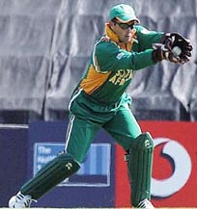

We always move towards the person with the ball (without getting too close) to make it more difficult for the defender to get between us and intercept

Timing

Correct timing is essential – we must finish moving away from the post when someone wants to pass us the ball – they should never have to wait.  As a rule of thumb you should allow your elastic to pull you in when the person “two away” starts to move away from the post | 

Things to Avoid

“Strangled”. If you run between another attacker and the post you will strangle yourself on their elastic. Stay in the same area, allow your elastic to pull you towards the post and then move away to receive the ball | 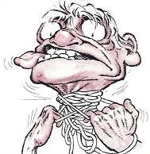
“Headless chicken” – if you run randomly round the post your elastic will end up in knots  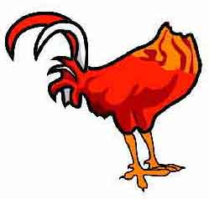 | 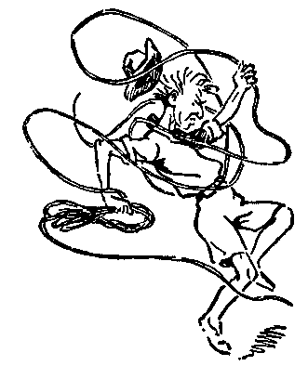
“Timber” – if you are all pulling on elastic at the same side of the post you will pull it over – use the space and spread out and pull from all directions. | 

